Hip Flexor Spica

- Start with a 6” Double wrap and bend the injured leg slightly at the knee and hip.

- Place the wrap at the middle of the thigh. Start on the medial side of the leg and wrap around the thigh laterally.
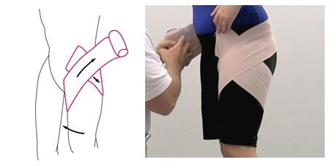

- Roll the wrap up and behind the back and around the abdomen, then around the thigh.
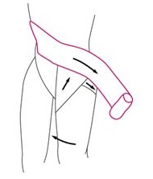

- Continue this pattern until you come to the end of the wrap.
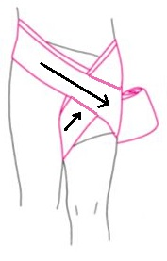

- Secure the wrap by taping the fabric wrap in the same pattern your applied it--placing a strip of tape around your thigh, lower back and back down to your thigh where the wrap ends

