Groin Spica

- Start with a 6” Double wrap, bend the injured leg slightly at the knee and hip, and slightly internally rotated.

- Place the wrap at the middle of the thigh. Start on the lateral side of the leg and wrap around the thigh medially.
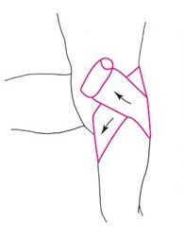

- Roll the wrap up, around the abdomen, and behind the back, then around the thigh.
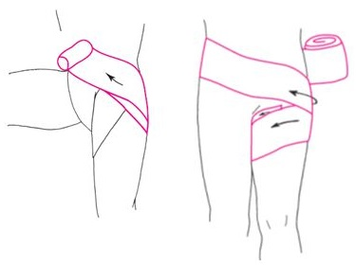

- Continue this pattern until you come to the end of the wrap.
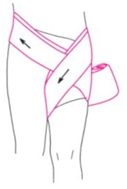

- Secure the wrap by taping the fabric wrap in the same pattern your applied it--placing a strip of tape around your thigh, lower back and back down to your thigh where the wrap ends
