- Anchor Strips | 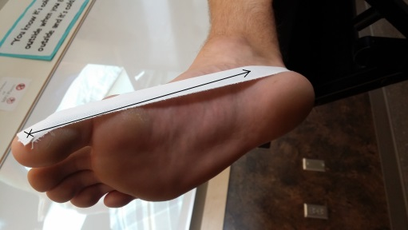  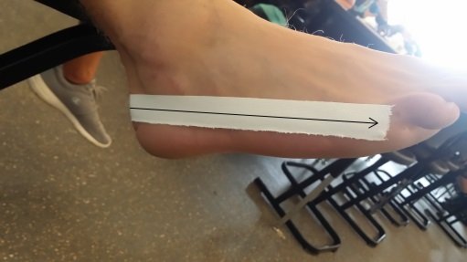 | After applying tape adherent to the bottom and sides of foot, use 1” tape strips, starting on the 1st phalange and bring it around the back of the heel and ending on the distal head of the 5th metatarsal
- Arch Support Strips | 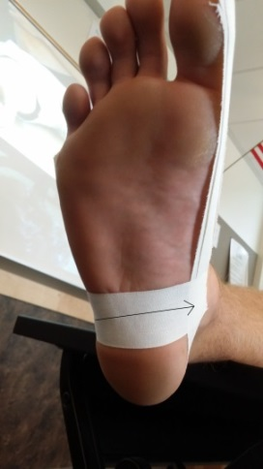 | Starting on the lateral side of the anchor just in front of the calcaneus, pull the tape under the foot towards the medial side of the anchor
2b. Arch Strips Cont. | 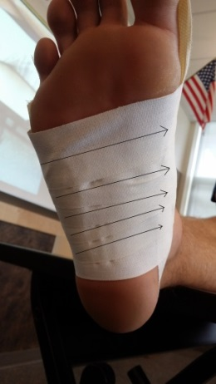 | Continue applying individual arch support strips, overlapping at least halfway until you reach the distal heads of the 1st and 5th metatarsals
- Pre Wrap | 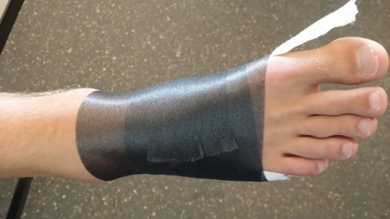 | Apply pre wrap around the foot, covering the arch support strips
- Cover Tape | 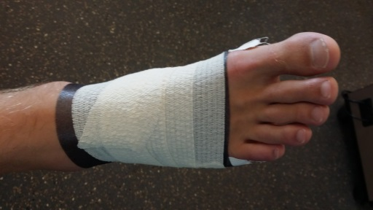 | Apply elastic stretch tape around the foot in a continuous fashion until the arch support strips are covered

